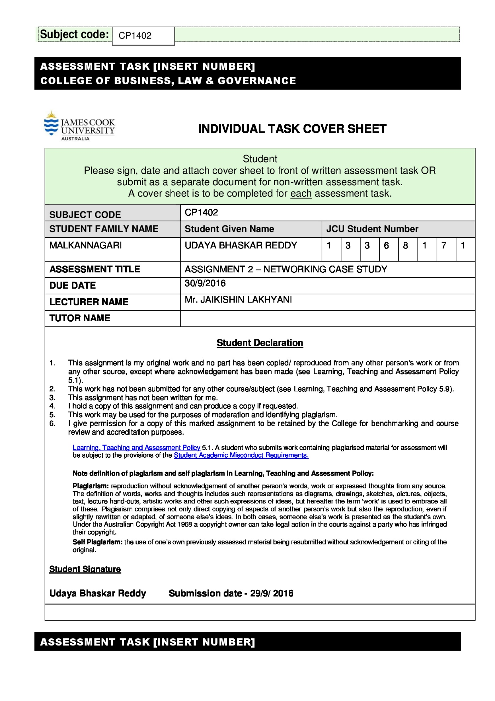

**CP1402 Assignment**

**Networking Case Study**

**Assignment Breakdown:**

**Scenario:**

A major Australian data analytics company wants to assess and redesign their network. They are opening new branches in Brisbane and Adelaide, which will require new equipment. They have existing contracts and hardware to maintain fibre optic leased line WAN links between sites.

PART 1 - Network specifications and diagram.

PART 2 - Subnetting the network using VLSM, and assigning IP addresses to the appropriate devices

PART 3 - Researching appropriate devices justifying choices (feasibility, efficiency, etc.) with a Weighted Scoring Model (WSM) and a documented report.

PART 4 - Security by applying Access Control Lists (ACLs) to filter traffic.

**PART 1 - Network specifications and diagram:**

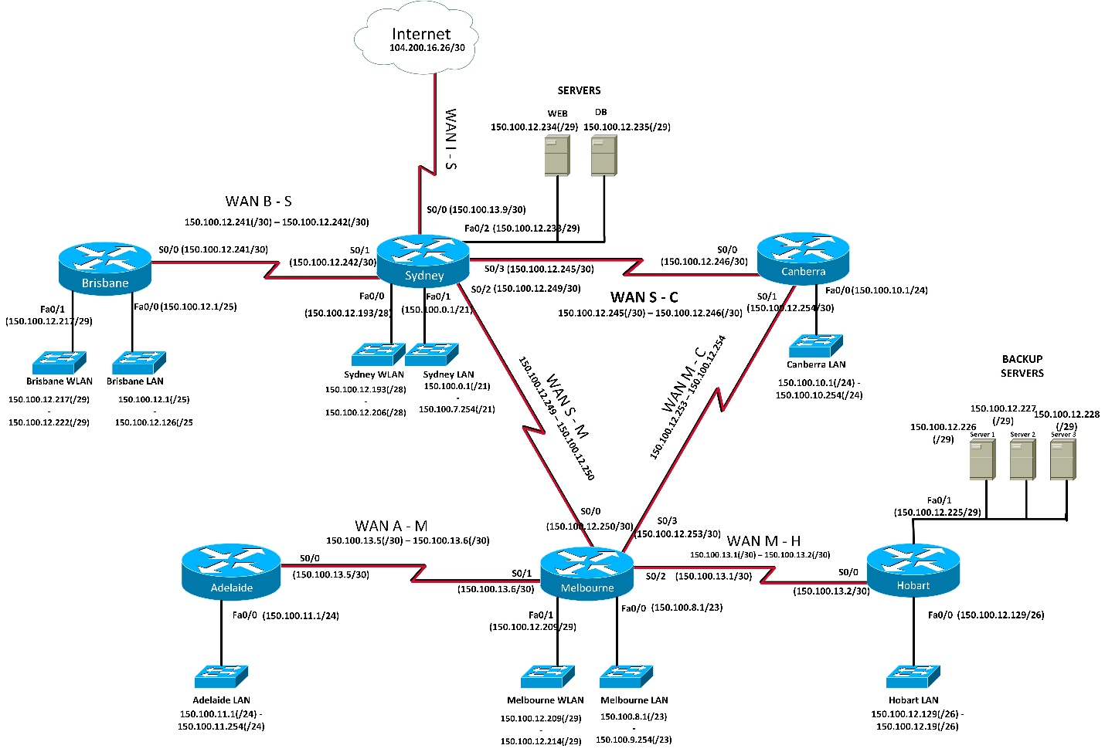

**PART 2 - Subnetting the network using VLSM, and assigning IP addresses to the appropriate devices.**

We choose a public class B network address 150.100.0.0 and subnet this block of addresses to optimize spare addresses for future expansion. A class B network is capable of supporting **216** (65536) hosts and that is more than required for this network. The number of hosts for each location are listed below.

|  |  |  |
| --- | --- | --- |
| **Location** | **Workstations** | **WLAN addresses** |
| Sydney | 910 | 14 |
| Melbourne | 200 | 6 |
| Brisbane | 40 | 6 |
| Canberra | 120 |  |
| Adelaide | 70 |  |
| Hobart | 20 |  |

Sydney, Melbourne and Brisbane each include a wireless LAN for clients to use.

We are to add 100% to each subnet to allow for growth in the number of hosts specified for each LAN. Hence the number of hosts per subnet should be multiplied by 2 for the workstations. We are not required to allow for any growth in the number of servers or size of WLANs. Hence, their number remains the same.

We do not need to use subnets of the same size for each network. For example, we need fewer addresses for the network on the Hobart router, that has 20(*2) hosts than we need for the network on the Sydney router that has 910(*2) hosts. We need 2 hosts for every WAN link. The number of hosts per subnet and the subnet size required is listed in the table below.

|  |  |  |  |
| --- | --- | --- | --- |
| **LAN** | **Number of Hosts per Subnet** (largest to smallest) | **Subnet Size** | **Number of Host bits required** |
| Sydney LAN | (910 * 2) =1820 | 2048 | 11 |
| Melbourne-LAN | (200 * 2) =400 | 512 | 9 |
| Canberra-LAN | (120 * 2) =240 | 256 | 8 |
| Adelaide-LAN | (70 * 2) =140 | 256 | 8 |
| Brisbane LAN | (40 * 2) =80 | 128 | 7 |
| Hobart-LAN | (20 * 2) =40 | 64 | 6 |
| Sydney-WLAN | 14 | 16 | 4 |
| Melbourne-WLAN | 6 | 8 | 3 |
| Brisbane -WLAN | 6 | 8 | 3 |
| Hobart-servers | 3 | 8 | 3 |
| Sydney-servers | 3 | 8 | 3 |
| WAN B-S | 2 | 4 | 2 |
| WAN S-C | 2 | 4 | 2 |
| WAN S-M | 2 | 4 | 2 |
| WAN M-C | 2 | 4 | 2 |
| WAN M-H | 2 | 4 | 2 |
| WAN A-M | 2 | 4 | 2 |
| WAN I-S | 2 | 4 | 2 |

**Table 1: Subnets**

|  |  |  |  |  |  |  |  |
| --- | --- | --- | --- | --- | --- | --- | --- |
| **Subnet Name** | **Subnet Address** | **Subnet Mask** | **First Usable address** | **Last Usable Address** | **Broadcast Address** | **Static Address Range** | **DHCP Address Range** |
| Sydney LAN | 150.100.0.0  (/21) | 255.255.248.0  (/21) | 150.100.0.1  (/21) | 150.100.7.254  (/21) | 150.100.7.255  (/21) |  | 150.100.0.2 – 150.100.7.254 |
| Melbourne LAN | 150.100.8.0  (/23) | 255.255.254.0  (/23) | 150.100.8.1  (/23) | 150.100.9.254  (/23) | 150.100.9.255 (/23) |  | 150.100.8.2 – 150.100.9.254 |
| Canberra LAN | 150.100.10.0  (/24) | 255.255.255.0  (/24) | 150.100.10.1  (/24) | 150.100.10.254  (/24) | 150.100.10.255 (/24) |  | 150.100.10.2 – 150.100.10.254 |
| Adelaide LAN | 150.100.11.0  (/24) | 255.255.255.0  (/24) | 150.100.11.1  (/24) | 150.100.11.254  (/24) | 150.100.11.255 (/24) |  | 150.100.11.2 – 150.100.11.254 |
| Brisbane LAN | 150.100.12.0  (/25) | 255.255.255.128 (/25) | 150.100.12.1  (/25) | 150.100.12.126  (/25) | 150.100.12.127 (/25) |  | 150.100.12.2 – 150.100.12.126 |
| Hobart LAN | 150.100.12.128  (/26) | 255.255.255.192 (/26) | 150.100.12.129  (/26) | 150.100.12.190  (/26) | 150.100.12.191 (/26) |  | 150.100.12.130 – 150.100.12.190 |
| Sydney WLAN | 150.100.12.192  (/28) | 255.255.255.240 (/28) | 150.100.12.193  (/28) | 150.100.12.206  (/28) | 150.100.12.207 (/28) |  | 150.100.12.194 – 150.100.12.206 |
| Melbourne WLAN | 150.100.12.208  (/29) | 255.255.255.248 (/29) | 150.100.12.209  (/29) | 150.100.12.214  (/29) | 150.100.12.215 (/29) |  | 150.100.12.210 – 150.100.12.214 |
| Brisbane WLAN | 150.100.12.216  (/29) | 255.255.255.248 (/29) | 150.100.12.217  (/29) | 150.100.12.222  (/29) | 150.100.12.223 (/29) |  | 150.100.12.218 – 150.100.12.222 |
| Hobart-Servers | 150.100.12.224  (/29) | 255.255.255.248 (/29) | 150.100.12.225  (/29) | 150.100.12.230  (/29) | 150.100.12.231 (/29) | 150.100.12.225 – 150.100.12.230 |  |
| Sydney-Servers | 150.100.12.232  (/29) | 255.255.255.248 (/29) | 150.100.12.233  (/29) | 150.100.12.238  (/29) | 150.100.12.239 (/29) | 150.100.12.233 – 150.100.12.238 |  |
| WAN B-S | 150.100.12.240  (/30) | 255.255.255.252 (/30) | 150.100.12.241  (/30) | 150.100.12.242  (/30) | 150.100.12.243 (/30) | 150.100.12.241 – 150.100.12.242 |  |
| WAN S-C | 150.100.12.244  (/30) | 255.255.255.252 (/30) | 150.100.12.245  (30) | 150.100.12.246  (/30) | 150.100.12.247 (/30) | 150.100.12.245 – 150.100.12.246 |  |
| WAN S-M | 150.100.12.248  (/30) | 255.255.255.252 (/30) | 150.100.12.249  (/30) | 150.100.12.250  (/30) | 150.100.12.251 (/30) | 150.100.12.249 –  150.100.12.250 |  |
| WAN M-C | 150.100.12.252  (/30) | 255.255.255.252 (/30) | 150.100.12.253  (/30) | 150.100.12.254  (/30) | 150.100.12.255  (/30) | 150.100.12.253-150.100.12.254 |  |
| WAN M-H | 150.100.13.0  (/30) | 255.255.255.252 (/30) | 150.100.13.1  (/30) | 150.100.13.2  (/30) | 150.100.13.3  (/30) | 150.100.13.1-150.100.13.2 |  |
| WAN A-M | 150.100.13.4  (/30) | 255.255.255.252  (/30) | 150.100.13.5  (/30) | 150.100.13.6  (/30) | 150.100.13.7  (/30) | 150.100.13.5-150.100.13.6 |  |
| WAN I – S | 150.100.13.8  (/30) | 255.255.255.252  (/30) | 150.100.13.9  (/30) | 150.100.13.10  (/30) | 150.100.13.11  (/30) | 150.100.13.9-150.100.13.10 |  |

**Explaining the workings of the table:**

Step 1:

The Sydney LAN requires the largest number of hosts in the subnet, which is 1820 host addresses. This subnet requires 11 host bits for the host portion of the address. As we have 16 host bits in our original class B network 150.100.0.0, we have 5 bits for the subnet portion after allocation 11 bits for the host portion, giving us 32 subnets(total) with 2048 hosts(total) per subnet as shown below.

150 100 0 0 /21

10010110 . 01100100| . 00000|000 . 00000000|

Network prefix | Subnet | Host Number bits|

There will be 32 subnets in total with 2048 hosts per subnet. The first eight subnets are listed below in the table in the decimal format.

|  |  |
| --- | --- |
| /21 Subnets | Used/Spare |
| 150.100.0.0 /21 | Used |
| 150.100.8.0 /21 | Spare |
| 150.100.16.0 /21 | Spare |
| 150.100.24.0 /21 | Spare |
| 150.100.32.0 /21 | Spare |
| 150.100. 40.0/21 | Spare |
| 150.100.48.0 /21 | Spare |
| 150.100.56.0 /21 | Spare |

The Sydney LAN requires only 1820 host addresses which can be allocated in the first subnet itself.

Step 2:

We choose the next available subnet, in this case 150.100.8.0 /25 and subnet it for the next smaller network, Melbourne LAN(requires 9 bits for 400 host addresses, and therefore a /23 network prefix).

Since we are subnetting a /21 to /23 there will be 2 subnet bits, providing 4 subnets(total) with 512 hosts (total) on each subnet as shown below.

|  |  |
| --- | --- |
| /23 subnets | Used/Spare |
| 150.100.8.0 (/23) | Used |
| 150.100.10.0 (/23) | Spare |
| 150.100.12.0 (/23) | Spare |
| 150.100.14.0 (/23) | Spare |

The Melbourne LAN requires 400 host addresses which can be allocated in the first subnet itself.

Step 3:

For Canberra LAN, we require 240 host addresses which we can allocate subnetting the next available subnet, that is 150.10.10.0/23. Since we require only 240 host address, we choose 8 bits to further subnet this network. In the same way, we keep subnetting the next available spare subnet based on the number of host bits required. The listing of the subnet size and the host bits is mentioned in the first table.

Step 4:

After allocating addresses by subnetting the LANs, we later subnet the WLANs sequentially as they require fewer number of host bits than the LANs in this case. We then subnet the servers, which require even fewer host bits. The Hobart servers require 4 addresses and the Sydney server requires 3 addresses. So, we allocate 3 host bits for subnetting. We then subnet the WANs which require 2 usable addresses for the interfaces. So,we allocate 2 host bits for this.

The next part deals with allocating ranges.

The usable range for all the LANs and the WLANs starts from the first usable addresses (gateway address) to the last usable address (excluding the Broadcast address).When we subnet a network, we cannot use the first and the last address, which is the broadcast address.

The Static Address Range is allocated to the servers. And the DHCP range starts from the second usable address to the last usable address on the particular LAN subnets. Since we allocated only two host bits for subnetting the WANs, there are only two usable addresses for the WANs.

The Subnet addresses for all the LANs, Servers, and the WANs are listed below along with the binary/decimal formats.

|  |  |  |
| --- | --- | --- |
| **Location** | **Subnet address(decimal)** | **Subnet Address(Binary)** |
| Sydney LAN | 150.100.0.0  (/21) | 10010110. 01100100. 00000000. 00000000 |
| Melbourne LAN | 150.100.8.0  (/23) | 10010110. 01100100. 00001000. 00000000 |
| Canberra LAN | 150.100.10.0  (/24) | 10010110. 01100100. 00001010. 00000000 |
| Adelaide LAN | 150.100.11.0  (/24) | 10010110. 01100100. 00001011. 00000000 |
| Brisbane LAN | 150.100.12.0  (/25) | 10010110. 01100100. 00001100. 00000000 |
| Hobart LAN | 150.100.12.128  (/26) | 10010110. 01100100. 00001010. 10000000 |
| Sydney WLAN | 150.100.12.192  (/28) | 10010110. 01100100. 00001010. 11000000 |
| Melbourne WLAN | 150.100.12.208  (/29) | 10010110. 01100100. 00001010. 11010000 |
| Brisbane WLAN | 150.100.12.216  (/29) | 10010110. 01100100. 00001010. 11011000 |
| Hobart-Servers | 150.100.12.224  (/29) | 10010110. 01100100. 00001010. 11100000 |
| Sydney-Servers | 150.100.12.232  (/29) | 10010110. 01100100. 00001010. 11101000 |
| WAN B-S | 150.100.12.240  (/30) | 10010110. 01100100. 00001010. 11110000 |
| WAN S-C | 150.100.12.244  (/30) | 10010110. 01100100. 00001010. 11110100 |
| WAN S-M | 150.100.12.248  (/30) | 10010110. 01100100. 00001010. 11110100 |
| WAN M-C | 150.100.12.252  (/30) | 10010110. 01100100. 00001010. 11111000 |
| WAN M-H | 150.100.13.0  (/30) | 10010110. 01100100. 00001101. 00000000 |
| WAN A-M | 150.100.13.4  (/30) | 10010110. 01100100. 00001101. 00000100 |
| WAN I – S | 150.100.13.8  (/30) | 10010110. 01100100. 00001101. 00001000 |

**Table 2:**

**Router Interfaces:**

|  |  |  |  |
| --- | --- | --- | --- |
| **Location** | **Interface** | **IP Address** | **Subnet Mask** |
| Sydney | S0/0 | 150.100.13.9(/30) | 255.255.255.252(/30) |
| Sydney | S0/1 | 150.100.12.242(/30) | 255.255.255.252(/30) |
| Sydney | S0/2 | 150.100.12.249(/30) | 255.255.255.252(/30) |
| Sydney | S0/3 | 150.100.12.245(/30) | 255.255.255.252(/30) |
| Sydney | Fa0/0 | 150.100.12.193(/28) | 255.255.255.240 (/28) |
| Sydney | Fa0/1 | 150.100.0.1(/21) | 255.255.248.0 (/21) |
| Sydney | Fa0/2 | 150.100.12.233(/29) | 255.255.255.248 (/29) |
| Melbourne | S0/0 | 150.100.12.250(/30) | 255.255.255.252(/30) |
| Melbourne | S0/1 | 150.100.13.6(/30) | 255.255.255.252(/30) |
| Melbourne | S0/2 | 150.100.13.1(/30) | 255.255.255.252(/30) |
| Melbourne | S0/3 | 150.100.12.253(/30) | 255.255.255.252(/30) |
| Melbourne | Fa0/0 | 150.100.8.1(/23) | 255.255.254.0(/23) |
| Melbourne | Fa0/1 | 150.100.12.209(/29) | 255.255.255.248 (/29) |
| Canberra | S0/0 | 150.100.12.246(/30) | 255.255.255.252(/30) |
| Canberra | S0/1 | 150.100.12.254(/30) | 255.255.255.252(/30) |
| Canberra | Fa0/0 | 150.100.10.1(/24) | 255.255.255.0 (/24) |
| Adelaide | S0/0 | 150.100.13.5(/30) | 255.255.255.252(/30) |
| Adelaide | Fa0/0 | 150.100.11.1(/24) | 255.255.255.0(/24) |
| Brisbane | S0/0 | 150.100.12.241(/30) | 255.255.255.252(/30) |
| Brisbane | Fa0/0 | 150.100.12.1(/25) | 255.255.255.128 (/25) |
| Brisbane | Fa0/1 | 150.100.12.217(/29) | 255.255.255.248 (/29) |
| Hobart | S0/0 | 150.100.13.2(/30) | 255.255.255.252(/30) |
| Hobart | Fa0/0 | 150.100.12.129(/26) | 255.255.255.192 (/26) |
| Hobart | Fa0/1 | 150.100.12.225(/29 | 255.255.255.248 (/29) |

**Table 3 - Servers**

|  |  |  |  |
| --- | --- | --- | --- |
| **Location** | **Server Name** | **IP Address** | **Subnet Mask** |
| Sydney | Web | 150.100.12.234(/29) | 255.255.255.248 (/29) |
| Sydney | PB | 150.100.12.235(/29) | 255.255.255.248 (/29) |
| Hobart | Server 1 | 150.100.12.226(/29) | 255.255.255.248 (/29) |
| Hobart | Server 2 | 150.100.12.227(/29) | 255.255.255.248 (/29) |
| Hobart | Server 3 | 150.100.12.228(/29) | 255.255.255.248 (/29) |

**Part 3: Project Procurement Plan:**

**Executive Summary:**

This project procurement plan is for the Adelaide and Brisbane networks. The Australian Data Analytics Company are opening new branches in these areas which require new equipment. The equipment should include two routers, two switches (one for Adelaide and the other for Brisbane) and a wireless access point. We are to compare these devices based on their cost, performance and other criteria as explained in the detailed analysis below.

**Weighted Decision Matrix - hardware resource requirements analysis :**

The budget for all procurement is $ 10000. So, we assign maximum budgets for all the devices as listed below.

Routers for Adelaide - $ 1000

Routers for Brisbane - $ 2000

Switches for Brisbane – $ 2500

Switches for Adelaide - $ 3000

Wireless Access Points - $ 1500

**Weighted Decision Matrix:**

We use the Weighted Decision Matrix to compare the various devices and pick the equipment that is best suited to the situation. When we compare different requirements, we assign a value of importance to each requirement for the specific situation. The “weight” for each requirement is a numerical value. We use odd values to describe the importance of the requirement as listed in the table below.

**Weight table**

|  |  |
| --- | --- |
| **Weight** | **Requirement** |
| **0** | Therequirement does not apply to this scenario |
| **1** | The requirement is not very important |
| **3** | The requirement must be met |
| **5** | The requirement is critical |

**Accessing the options:**

We give a score to each item if it meets the requirement. Just like the “weight” value, the “score” is also assigned a numerical value. We access each item by giving scores based on the requirements it meets, as listed in the score table below.

|  |  |
| --- | --- |
| **Score** | **Requirement** |
| 0 | The requirement isn’t met at all |
| 2 | The requirement is partially met, but not completely |
| 4 | The requirement has been met |
| 6 | The item exceeds the requirement |

**Score Table**

**Calculating the Scores:**

The “score” for each product requirement is multiplied by its “weight” to get the “Weighted Score”. The “Total Weighted Score” is calculated by adding all the invidividual “Weighted Scores” of the product based on different factors and critieria. And in the end, based on the “Total Weighted Score”, we choose the best product for our needs. It is explained below:

Total Weighted Score = (weight1 * score1) + (weight2 * score2) +…..

**Reference website for selecting products:**

**http://www.umart.com.au/umart1/pro/index.phtml?bid=2**

**SWITCHES**

**Criteria for Switches:**

The Adelaide network has 40 workstations and 6 WLAN addresses. We need to add 100% to each subnet to allow for growth in the number of hosts for each LAN. We multiply the number of workstations by 2 and add the number of WLAN addresses to get the total number of ports. So, the Switches for this network require a minimum of 86 ports (40*2 workstations + 6 WLAN addresses). The Brisbane network has 70 workstations and the Switches for this network require a minimum of 140 (ie., 70 * 2) ports. These criteria must be met when the devices are purchased. Other essential criteria include the data transfer speed, which can be set to a minimum of 1000Mbps for the network to function in an efficient manner with a high data transfer rate. We can also check if the Switches are Managed or Unmanaged. As Managed Switches give more control over the LAN traffic and offer advanced features to control that traffic, it is essential we use managed switches for troubleshooting purposes.

**Switches for Brisbane:**

The following table lists the Switches with their cost, no of ports, speed and other factors(Managed/Unmanaged). Since we need atleast 86 ports for this network, we use multiple switches based on the number of ports.

|  |  |  |  |  |
| --- | --- | --- | --- | --- |
| **MODEL** | **NO Of PORTS (>=86)** | **COST ($)** | **SPEED(Mbps)** | **MANAGED** |
| Cisco SF 300-48PP 48-port 10/100 PoE Managed Switch | 48*2 = 96 | 1099*2 = 2198 | 1000 | Yes |
| D-link DES-1210-52(48 + 2UTP + 2SFP) | 52*2 = 104 | 399*2 = 798 | 100 | No |
| NETGEAR GS728TPP-100AJS Switch 24-port GbE with PoE+ | 24 * 4 = 96 | 769 * 4 = 3076 | 1000 | Yes |
| Cisco SG 300-52P 48 Port Gigabit PoE Managed Switch | 52 * 2 = 104 | 2099 *2 = 4198 | 1000 | Yes |
| D-Link DGS-1210-52 48-Port | 48*2 = 96 | 555 | 1000 | Yes |

**Weighted Decision Matrix**

|  |  |  |  |  |  |
| --- | --- | --- | --- | --- | --- |
| **Requirements** | **Cost** | **No of Ports** | **Speed** | **Managed** | **Total Weighted Score** |
| Description | < $ 2500 | >=86 | >=1000Mbps | Yes |  |
| Weight | 3 | 5 | 3 | 1 |  |
| Score Cisco SF 300-48PP | 4 | 6 | 4 | 6 | 60 |
| Score D-link DES-1210-52 | 6 | 6 | 0 | 0 | 48 |
| Score NETGEAR GS728TPP | 2 | 4 | 4 | 4 | 42 |
| Score Cisco SG 300-52P | 0 | 6 | 6 | 6 | 54 |
| Score D-Link DGS-1210-52 48-Port | 6 | 6 | 2 | 2 | 56 |

Total Weighted Score = [weight(cost) * score(cost)] + [(weight(no of ports) * score(no of ports)] + [weight(speed) * score(speed)] + [(weight(Managed) * score(Managed)]

Based on the Weighted Decision Matrix, the “Cisco SF 300-48PP” Switch scores a total of 60 and is the best product that fits in our budget and requirements.

**Switches for Adelaide:**

We list out the various specifications of the product in the table below. We need 140 ports for this network, so we use multiple switches based on the number of ports.

|  |  |  |  |  |
| --- | --- | --- | --- | --- |
| **Model** | **No of ports (>=140)** | **Cost ($)** | **Speed(Mbps)** | **Managed** |
| Cisco SF 300-48P | 48 * 3 = 144 | 999 * 3 = 2997 | 1000 | Yes |
| D-link DES-1210-52(48 + 2UTP + 2SFP) | 52 * 3 = 156 | 399 * 3 = 1197 | 100 | No |
| Netgear GS728TP Prosafe 24-port (+ 4 SFP) | 28 * 5 = 140 | 475 * 35= 2375 | 1000 | Yes |
| Cisco SG 300-52P 48 Port Gigabit PoE Managed Switch | 52 * 3 = 156 | 2099 * 3 = 6297 | 1000 | Yes |
| HP J9981A 1820-48G Switch | 48 * 3 = 144 | 839 * 3 = 2517 | 1000 | Yes |

**Weighted Decision Matrix**

|  |  |  |  |  |  |
| --- | --- | --- | --- | --- | --- |
| **Requirements** | **Cost** | **No of Ports** | **Speed** | **Managed** | **Total Weighted Score** |
| Description | < $ 3000 | >=140 | >=1000Mbps | Yes |  |
| Weight | 3 | 5 | 3 | 1 |  |
| Score Cisco SF 300-48P | 4 | 6 | 4 | 4 | 58 |
| Score D-link DES-1210-52 | 6 | 6 | 0 | 0 | 48 |
| Score Netgear GS728TP | 4 | 4 | 4 | 4 | 48 |
| Score Cisco SG 300-52P | 0 | 6 | 6 | 6 | 54 |
| Score HP J9981A 1820-48G | 4 | 6 | 4 | 0 | 56 |

Total Weighted Score = [weight(cost) * score(cost)] + [(weight(no of ports) * score(no of ports)] + [weight(speed) * score(speed)] + [(weight(Managed) * score(Managed)]

Based on the Weighted Decision Matrix, the “Cisco SF 300-48P” Switch scores a total of 58 and is the best product that fits in our budget and requirements.

**ROUTERS:**

**Criteria for Routers:**

We allocate $ 1000 and $ 2000 budget for each router for Adelaide and Brisbane respectively. The Routers must have a minimum number of 2 ports. The wifi speeds must be more than 1000Mbps to allow for faster connectivity. Checking for the 5GHz frequency bands is also an essential criteria, since it reduces noise, fewer disconnects and faster data rates. 802.11 ac Wireless Networking Standard can also be checked to ensure high throughput on the 5GHz band. 5GHz frequency band can also be used as a criteria when comparing routers as it offers less noise, less interference, better speeds, a more stable connection.

**Router for Adelaide:**

|  |  |  |  |  |
| --- | --- | --- | --- | --- |
| **Model** | **No of ports** | **Cost ($)** | **Wifi Speed(Mbps)** | **5GHz band** |
| Asus RT-AC 88U Dual band AC3100 | 2 | $ 419 | 5GHz- 2167Mbps  2.4GHz-1000Mbps | Yes |
| Cisco 2921/k9 w/3 GE | 6 | $ 1999 | Gigabit Ethernet | Yes |
| Netgear R8500 Nighthawk AC5300 Triband Wifi Router | 7 | $ 649 | Combined speed of 5.3 Gbps | Yes |
| TP -Link TL -MR6400 Wireless 300Mbps N 4G LTE Router | 4 | $ 162 | 300Mbps at 2.4 GHz | No |
| Cisco RV 220W Wireless-N Network Security Firewall Router | 5 | $ 290 | Gigabit Ethernet | Yes |

**Weighted Decision Matrix:**

|  |  |  |  |  |  |
| --- | --- | --- | --- | --- | --- |
| **Requirements** | **Cost** | **No of ports** | **Speed** | **5GHz Band** | **Total Weighted Score** |
| Description | < $1000 | >2 | >1000Mbps | Yes |  |
| Weight | 3 | 5 | 3 | 1 |  |
| Score Asus RT-AC 88U | 4 | 2 | 4 | 4 | 38 |
| Score Cisco 2921/k9 | 0 | 6 | 6 | 4 | 52 |
| Score Netgear R8500 | 4 | 6 | 4 | 4 | 58 |
| Score TPLink TL – MR6400 | 6 | 4 | 2 | 0 | 44 |
| Score Cisco RV 220W | 4 | 4 | 4 | 4 | 48 |

Total Weighted Score = [weight(cost) * score(cost)] + [(weight(no of ports) * score(no of ports)] + [weight(speed) * score(speed)] + [(weight(5GHz Band) * score(5GHz Band)]

Based on the Weighted Decision Matrix, the “Netgear R8500 Nighthawk AC5300 Triband Wifi Router” scores a total of 58 and is the best product that fits our budget ($1000) and other requirements.

**Router for Brisbane:**

|  |  |  |  |  |
| --- | --- | --- | --- | --- |
| **Model** | **No of ports** | **Cost ($)** | **Wifi Speed(Mbps)** | **5GHz band** |
| Asus RT-AC5300 Wireless-AC5300 Tri-Band Gigabit Router - NBN Ready | 6 | $ 489 | 5GHz- 2167Mbps  2.4GHz-1000Mbps | Yes |
| Cisco 2921/k9 w/3 GE | 6 | $ 1999 | Gigabit Ethernet | Yes |
| D-Link DIR-895L MU-MIMO AC3200 Ultra Wi-Fi Router | 4 | $ 649 | 5Ghz – 1300Mbps  2.4Ghz – 600Mbps | Yes |
| TP -Link TL -MR6400 Wireless 300Mbps N 4G LTE Router | 4 | $ 162 | 300Mbps at 2.4 GHz | No |
| Cisco 887VA ANNEX M Over POTS Router | 4 | $ 799 | Fast Ethernet | No |

**Weighted Decision Matrix:**

|  |  |  |  |  |  |
| --- | --- | --- | --- | --- | --- |
| **Requirements** | **Cost** | **No of ports** | **Speed** | **5GHz Band** | **Total Weighted Score** |
| Description | < $2000 | >2 | >1000Mbps | Yes |  |
| Weight | 3 | 5 | 3 | 1 |  |
| Score Asus RT-AC5300 | 4 | 6 | 4 | 4 | 58 |
| Score Cisco 2921/k9 | 4 | 6 | 6 | 4 | 64 |
| Score D-Link DIR-895L | 4 | 4 | 4 | 4 | 48 |
| Score TPLink TL – MR6400 | 6 | 4 | 2 | 0 | 44 |
| Score Cisco 887VA ANNEX | 4 | 4 | 4 | 2 | 46 |

Total Weighted Score = [weight(cost) * score(cost)] + [(weight(no of ports) * score(no of ports)] + [weight(speed) * score(speed)] + [(weight(5GHz Band) * score(5GHz Band)]

Based on the Weighted Decision Matrix, the “Cisco 2921/k9 w/3 GE” scores a total of 64 and is the best product that fits our budget ($2000) and requirements.

**Wireless Access Points for Brisbane:**

**Criteria for Wireless Access points:**

The cost of the wireless access points must not exceed $ 1500.The speeds must be in excess of 450 Mbps to allow for faster data rates. The IEEE wireless networking standard 802.11 ac offers several advantages by providing with high data transfer rates, noise reduction, channel management, more antenna options, etc., So, we can check if the access points abide by that standard. The number of RJ 45 ports can also be checked.

|  |  |  |  |
| --- | --- | --- | --- |
| **Model** | **Cost ($)** | **Speed** | **Wireless Standard**  **802.11ac** |
| DLink DAP-3690 Wireless N600 Dual Band | $ 1250 | 300Mbps in both 2.4GHz and 5GHz bands | No |
| Netgear WNDAP660 Prosafe 802.11n Dual Radio | $ 565 | 450Mbps | No |
| DLink DAP-2695 Wireless AC1750 | $399 | 1720Mbps throughput | Yes |
| Cisco AIR-AP1852I-Z-K9 802.11AC WAVE 2 | $939 | Wireless Transmission Speed is 1.69Gbps | Yes |
| Cisco AIR-CAP2602E-Z-K9 802.11n CAP w/CleanAir | $1199 | Wireless Transmission Speed is 450Mbps | No |

**Weighted Decision Matrix:**

|  |  |  |  |  |  |
| --- | --- | --- | --- | --- | --- |
| **Requirements** | **Cost** | **Speed** | **Wireless Standard 802.11ac** | **No of RJ 45 ports** | **Total Weighted Score** |
| Description | < $ 1500 | >450 Mbps | Yes | >=2 |  |
| Weight | 3 | 5 | 3 | 1 |  |
| Score DLink DAP-3690 | 4 | 2 | 0 | 4 | 26 |
| Score Netgear WNDAP660 | 6 | 4 | 0 | 4 | 32 |
| Score DLink DAP-2695 | 6 | 6 | 4 | 4 | 64 |
| Score Cisco AIR-AP1852I-Z-K9 | 6 | 6 | 4 | 6 | 66 |
| Score Cisco AIR-CAP2602E-Z-K9 | 4 | 4 | 0 | 2 | 34 |

Total Weighted Score = [weight(cost) * score(cost)] + [(weight(speed) * score(speed)] + [weight(Wireless Standard 802.11ac) * score(Wireless Standard 802.11ac)] + [(weight(No of RJ 45 ports) * score(No of RJ 45 ports)]

Based on the Total Weighted Score, the “Cisco AIR-AP1852I-Z-K9 802.11AC WAVE 2” scores a total of 66 and is the best product that suits in our budget and requirements.

**Budget:**

By using the Weighted Decision Matrix, we accessed the various devices and chosen the best product based on its score. The cost of the items (including multiple switches required) is listed in the table below.

|  |  |  |
| --- | --- | --- |
| **Product** | **Model** | **Cost ($)** |
| Router for Adelaide | Netgear R8500 Nighthawk AC5300 Triband Wifi Router | $649 |
| Router for Brisbane | Cisco 2921/k9 w/3 GE | $1999 |
| Switches for Adelaide (3) | Cisco SF 300-48P | 1129 * 3 = $3387 |
| Switches for Brisbane (2) | Cisco SF 300-48PP 48-port 10/100 PoE Managed Switch | 1099*2 = $2198 |
| Wireless Access Points | Cisco AIR-AP1852I-Z-K9 802.11AC WAVE 2 | $939 |

**Total Cost = $649 + $1999 + $3387 + $2198 +$939 = $9173**

**So, the total cost of all procurement is $9172 which comes under the budget we are allocated with.**

**Part 4: Security by applying access control lists to filter traffic**

**Part a: Access to the Internet and public backbone:**

|  |  |  |  |  |  |  |
| --- | --- | --- | --- | --- | --- | --- |
| **Router** | **I/face** | **In/Out** | **Permit/**  **Deny** | **Source** | **Destination** | **Port** |
| Sydney | S0/0 | in | permit | 104.200.16.26(/30) | 150.100.12.234 | 80 |
| Sydney | S0/0 | in | permit | 104.200.16.26(/30) | 150.100.12.234 | 443 |
| Sydney | S0/0 | in | deny | 104.200.16.26(/30) | any |  |
| Sydney | S0/0 | out | permit | any | 104.200.16.26(/30) | 80 |
| Sydney | S0/0 | out | permit | any | 104.200.16.26(/30) | 443 |

**Permit** established connections from the **Source Internet** (104.200.16.26/30) to the **Destination any** . Router is the **Sydney Router**. Serial interface is **s0/0.** Type is **“in”.**

**Part b:**

**Sydney and Melbourne:**

**Sydney**

|  |  |  |  |  |  |  |
| --- | --- | --- | --- | --- | --- | --- |
| **Router** | **I/face** | **In/out** | **Permit/**  **Deny** | **Source** | **Destination** | **Port** |
| Sydney | Fa0/1 | in | permit | 150.100.0.0(/21) | 104.200.16.26(/30) |  |
| Sydney | Fa0/1 | in | permit | 150.100.0.0(/21) | 150.100.12.232(/29) |  |
| Sydney | Fa0/0 | in | permit | 150.100.12.192(/28) | 104.200.16.26(/30) | 80 |
| Sydney | Fa0/0 | in | permit | 150.100.12.192(/28) | 104.200.16.26(/30) | 443 |
| Sydney | Fa0/0 | in | permit | 150.100.12.192(/28) | 150.100.12.234(/29) | 80 |
| Sydney | Fa0/0 | in | permit | 150.100.12.192(/28) | 150.100.12.234(/29) | 443 |
| Sydney | Fa0/0 | in | deny | 150.100.12.192(/28) | any |  |
| Sydney | Fa0/2 | out | permit | any | 150.100.12.234(/29) | 80 |
| Sydney | Fa0/2 | out | permit | any | 150.100.12.234(/29) | 443 |
| Sydney | S0/0 | in | deny | 104.200.16.26(/30) | 150.100.12.234(/29) |  |
| Sydney | Fa0/2 | out | permit | Any(established) | 150.100.12.235(/29) | 1433 |

**Permit** Sydney Web Server(**150.100.12.234/29**) to get **ICMP** ping requests(type-echo) via http(port 80) and https(port 443) from internal hosts. Interface is Fa0/2. Router is **Sydney**.

**Melbourne**

|  |  |  |  |  |  |  |
| --- | --- | --- | --- | --- | --- | --- |
| **Router** | **I/face** | **In/out** | **Permit/**  **Deny** | **Source** | **Destination** | **Port** |
| Melbourne | Fa0/0 | in | permit | 150.100.8.0(/23) | 104.200.16.26(/30) |  |
| Melbourne | Fa0/0 | in | permit | 150.100.8.0(/23) | 150.100.12.232(/29) |  |
| Melbourne | Fa0/1 | in | permit | 150.100.12.208(/29) | 104.200.16.26(/30) | 80 |
| Melbourne | Fa0/1 | in | permit | 150.100.12.208(/29) | 150.100.12.234(/29) | 80 |
| Melbourne | Fa0/1 | in | permit | 150.100.12.208(/29) | 104.200.16.26(/30) | 443 |
| Melbourne | Fa0/1 | in | permit | 150.100.12.208(/29) | 150.100.12.234(/29) | 443 |
| Melbourne | Fa0/1 | in | deny | 150.100.12.208(/29) | any |  |

**Part c:**

**Brisbane, Adelaide, and Canberra**

**Brisbane and Canberra WANs**

|  |  |  |  |  |  |  |
| --- | --- | --- | --- | --- | --- | --- |
| **Router** | **I/face** | **In/out** | **Permit/**  **Deny** | **Source** | **Destination** | **Port** |
| Sydney | S0/1 | in | permit | 150.100.12.240(/30) | 104.200.16.26(/30) | 80 |
| Sydney | S0/1 | in | permit | 150.100.12.240(/30) | 104.200.16.26(/30) | 443 |
| Sydney | S0/1 | in | permit | 150.100.12.240(/30) | 150.100.12.234(/29) | 80 |
| Sydney | S0/1 | in | permit | 150.100.12.240(/30) | 150.100.12.234(/29) | 443 |
| Sydney | S0/3 | in | permit | 150.100.12.244(/30) | 104.200.16.26(/30) | 80 |
| Sydney | S0/3 | in | permit | 150.100.12.244(/30) | 104.200.16.26(/30) | 443 |
| Sydney | S0/3 | in | permit | 150.100.12.244(/30) | 150.100.12.234(/29) | 80 |
| Sydney | S0/3 | in | permit | 150.100.12.244(/30) | 150.100.12.234(/29) | 443 |

**Adelaide WAN**

|  |  |  |  |  |  |  |
| --- | --- | --- | --- | --- | --- | --- |
| **Router** | **I/face** | **In/out** | **Permit/**  **Deny** | **Source** | **Destination** | **Port** |
| Melbourne | S0/1 | in | permit | 150.100.13.4(/30) | 104.200.16.26(/30) | 80 |
| Melbourne | S0/1 | in | permit | 150.100.13.4(30) | 104.200.16.26(/30) | 443 |
| Melbourne | S0/1 | in | permit | 150.100.13.4(/30) | 150.100.12.234(/29) | 80 |
| Melbourne | S0/1 | in | permit | 150.100.13.4(/30) | 150.100.12.234(/29) | 443 |

**Brisbane WLAN**

|  |  |  |  |  |  |  |
| --- | --- | --- | --- | --- | --- | --- |
| **Router** | **I/face** | **In/out** | **Permit/**  **Deny** | **Source** | **Destination** | **Port** |
| Brisbane | Fa0/1 | In | Permit | 150.100.12.216(/29) | 104.200.16.26(/30) | 80 |
| Brisbane | Fa0/1 | In | Permit | 150.100.12.216(/29) | 104.200.16.26(/30) | 443 |
| Brisbane | Fa0/1 | In | Permit | 150.100.12.216(/29) | 150.100.12.234(/29) | 80 |
| Brisbane | Fa0/1 | in | permit | 150.100.12.216(/29) | 150.100.12.234(/29) | 443 |
| Brisbane | Fa0/1 | in | deny | 150.100.12.216(/29) | any |  |

**Part d - Hobart**

|  |  |  |  |  |  |  |
| --- | --- | --- | --- | --- | --- | --- |
| **Router** | **I/face** | **In/out** | **Permit/**  **Deny** | **Source** | **Destination** | **Port** |
| Hobart | Fa0/1 | in | permit | 150.100.12.224(/29) | any |  |
| Hobart | Fa0/1 | out | permit | Any(established) | 150.100.12.224(/29) |  |
| Hobart | Fa0/0 | in | permit | 150.100.12.128(/26) | 150.100.12.224(/29) |  |
| Hobart | Fa0/1 | out | deny | any | 150.100.12.224(/29) |  |
| Hobart | Fa0/0 | in | permit | 150.100.12.128(/26) | 104.200.16.26(/30) |  |
| Hobart | Fa0/0 | in | permit | 150.100.12.128(/26) | 150.100.12.232(/29) |  |
| Hobart | Fa0/0 | in | permit | 150.100.12.128(/26) | 150.100.12.224(/29) |  |